SOUTHWEST SEMINARS PRESENTS
MOTHER EARTH, FATHER SKY 2016

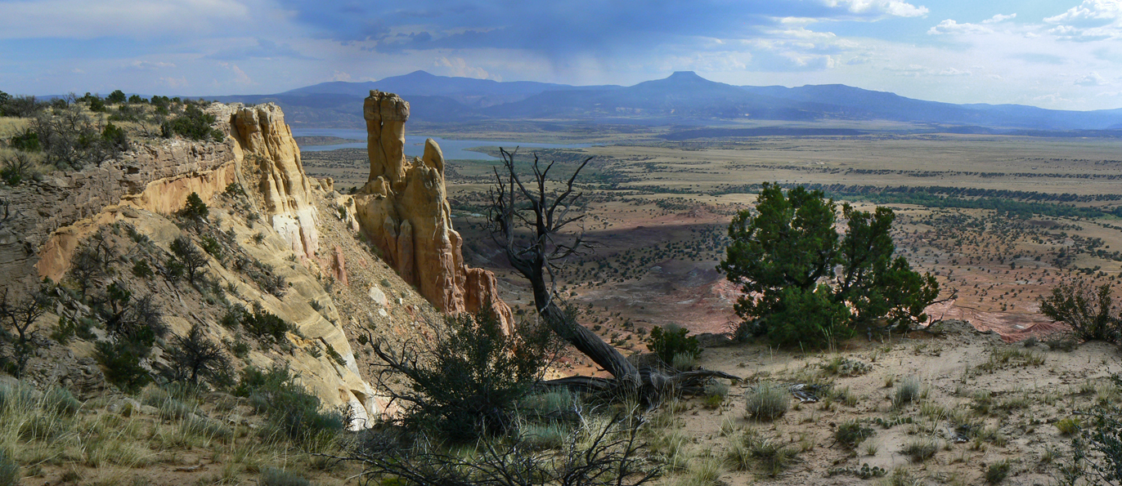

Monday nights at 6 pm at Hotel Santa Fe

TO HONOR AND ACKNOWLEDGE THE NEW MEXICO ENVIRONMENTAL LAW CENTER

A Public Program Graciously Assisted by Hotel Santa Fe, a Picuris Pueblo Enterprise

October 17 Jerry Rightman
Docent, Georgia O’Keeffe Museum, New Mexico Museum of Art, and Lecturer in Art, Architecture, and Art History
Georgia O’Keefe: Her Life and Inspiration in Nature

October 24 Dr. Robert K. Hitchcock
Former Professor and Chair, Department of Anthropology, Michigan State University; Author, Kalahari Communities: Bushmen and the Politics of the Environment in Southern Africa; Co-Editor, (w/M. Biesele/P. Schweitzer), Hunters and Gatherers in the Modern World: Conflict, Resistance, and Self-Determination; (w/A. Osborn), Endangered Peoples of Africa and the Middle East: Struggles to Survive and Thrive.
From Hunting to Herding: The Kalahari San and 2,000 Years of Adaptation

October 31 Dr. Richard I. Ford
Ethnobotanist and Archaeologist, Arthur F.Thurnau Professor Emeritus of Anthropology and Botany, University of Michigan (Ret.); Research Associate, Laboratory of Anthropology,
Museum of New Mexico, Department of Cultural Affairs
Evolution of the New Mexico Diet: Before and After Colonization

November 7 Sydney and Marie Davis
Sid, (B.S.): Assistant State Soil Scientist, USDA/Natural Resources Conservation Service
Marie, (M.S.): Chief Geologist, Placer County (Ca.) Water Agency
Both: Envionmental and agricultural land use, watershed management, and erosion control;
Co-Authors: ‘Early Agriculture in the Eastern Grand Canyon of Arizona’ in Geoarchaeology: An International Journal; ‘Erosional History of Colorado River through Glen/Grand Canyon’
Rising River: Colorado River, Grand Canyon, & Ancient Colorado Plateau Agriculture

November 14 Dr. E. James Dixon
Former Professor, Department of Anthropology and Director, Maxwell Museum of Anthropology, University of New Mexico; Affiliate, Institute of Arctic and Alpine Research, University of Colorado Research Associate, Denver Museum of Nature and Science; former Curator of Archaeology, University of Alaska Museum; Author, Archaeology, Climate, and Culture Change in Berengia
First Colonization of America

November 21 Lyle Balenquah, M.A. (Greasewood Clan, Bacavi Village, Third Mesa, Hopi)
Archaeologist, Independent cultural consultant for Hopi Tribe, Museum of Northern Arizona, and National Park Service, Hiking and River Guide in Grand Canyon; Study Leader, Archaeology Southwest/Southwest Seminars
Hopi Traditions and Water: Where Does the River Go?

November 28 Dr. Bryan Brown and Gary Cascio
Bryan: Ornithologist/Avian Ecologist; Grand Canyon fieldwork w/National Park Service; Environmental Consultant: University of Arizona, Northern Arizona University
Co-author, Grand Canyon Birds – Historical Notes, Natural History and Ecology; The Colorado River Through Grand Canyon – Natural History and Human Change.
Gary: Photographer and Graphic Designer; passionate amateur historian, researcher.
Historic New Mexico River Crossings

December 5 Steve Post
Principal Investigator, Zia Consulting and Author, ‘Ten Thousand Years of Living in Santa Fe’, in History of an Ancient City, D.G. Noble, Ed.; and former Deputy Director (ret.),
Office of Archaeological Studies, Museum of New Mexico, Department of Cultural Affairs
Native American Scouts at the Santa Fe Presidio in the 1700’s

December 12 Dr. Jon Hunner
Dr. Jon Hunner Professor and Chair, Department of History
New Mexico State University and Director, Public History Project
And Author, Inventing Los Alamos: The Growth of an Atomic Community;
J. Robert Oppenheimer, The Cold War, and The Atomic West; The Mesilla Valley: An Oasis in the Desert. (New Mexico Centennial Series)
Celebrating the National Parks: A Centennial Birthday Journey

December 19 Kirt Kempter
Volcanologist and Field Geologist; Study Leader, Smithsonian Journeys to Antarctica and Iceland; Former Fulbright Scholar; Field research in Costa Rica, Mexico and New Mexico;
Field Geologic Training for NASA Astronaut Candidate Program in New Mexico
Geology of Georgia O’Keeffe’s White Place and Black Place

$12 at the door ~ or ~ $100 for the Series of $10 Lectures

2017 Travels with A Scholar Study Tours

March 4-10: Mounds and Migrants: A Clash of the late Hohokam world

With Dr Jeffery clark, Dr. William Doelle and Lyle Balenquah (Bacavi, Third Mesa, Hopi)

May 25-June 1: Rafting the Yampa and the Green Rivers:
Archaeology of the Desert Archaic and Freemont Cultures with David Grant Noble

~And More to Come~

Southwest Seminars is a 501 (C)(3) Educational Non-Profit

Recipient 2008 Heritage Preservation Award, City of Santa Fe

Southwest Seminars

219 Ojo de la Vaca, Santa Fe, New Mexico 87508

Phone: (505) 466-2775E-mail: Southwestseminar@aol.com Website: SouthwestSeminars.org

~ We are committed to sensitive cultural education and work with those who share the same commitment~

